**How to make a Triptych in Photoshop**

Tim Keane 2018

1. Have your three images ready to go as JPGs. Best to put them in the same directory, if they are not already.

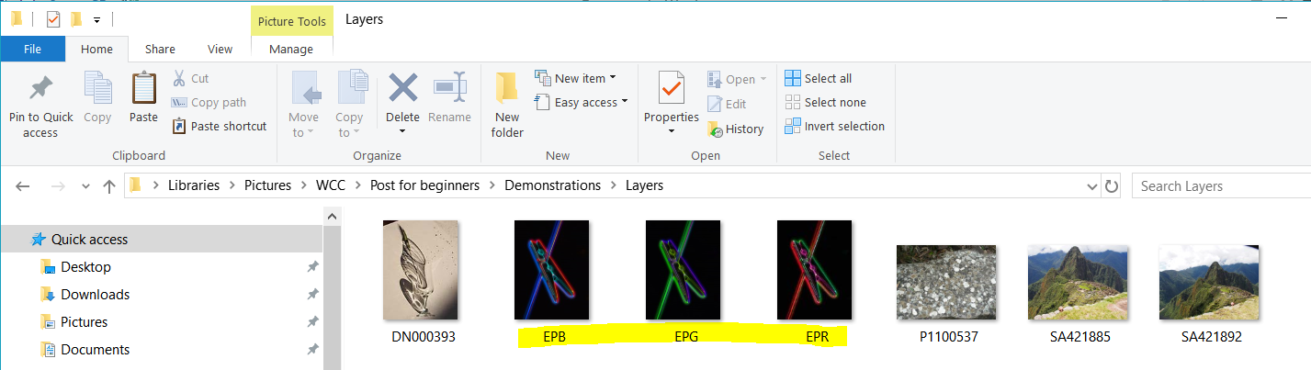

1. Open one of them in Photoshop. The one you want in the middle is best, but you can easily change later.
2. On the right hand side of Photoshop, right click the Background layer and select “Duplicate Layer”. Hit OK in the dialog box that comes up. This creates a new layer with the same image.

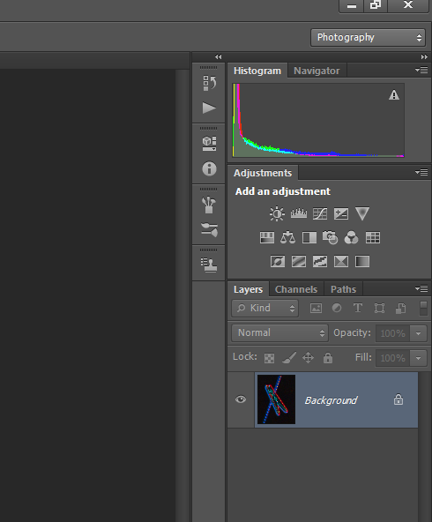 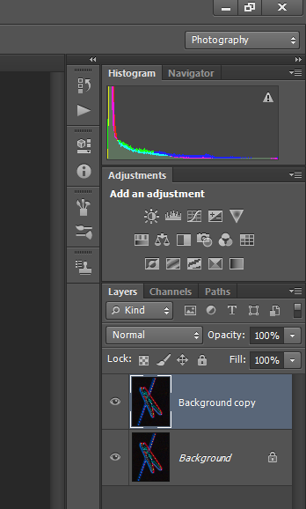

1. Go to the Image Menu and select Canvas size… In the dialog box which comes up, change the settings as follows (make sure you have percentage rather than centimetres, and Relative selected). Hit OK.

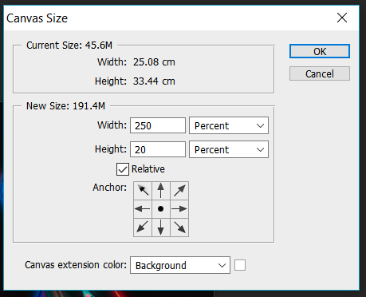

1. From the left, select the Zoom tool  then from the tool options at the top select Fit Screen 

You should now have something like this:

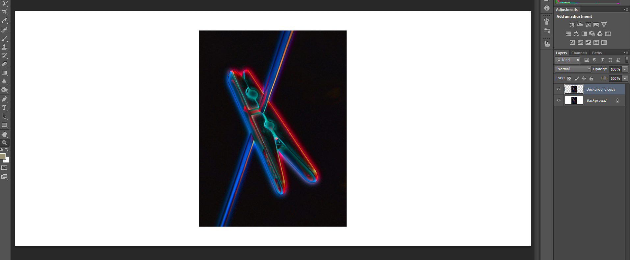

1. Select the background layer (by clicking on it in the right hand panel). Now go to the Layer Menu and scroll over New Fill Layer… and select Solid Colour. In the dialog box which comes up select the colour you want for the frame of the Triptych. If you can’t decide yet, pick White or Black and you can change it later.
2. From the File menu, select Place…, Find your next image, select it and hit Place. The new image will appear with a resizing grid over it, but ignore that for now and at the top of the screen select the tick 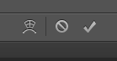
3. Choose the select tool  from the right hand side then click and drag the image to the left or right. Don’t be fussy about position at this stage.
4. Repeat steps 6 and 7 for the last of the three images. Hopefully it is starting to look like a Triptych now.
5. To move a different image/ layer simply click on that layer on the Layers panel - right hand side.

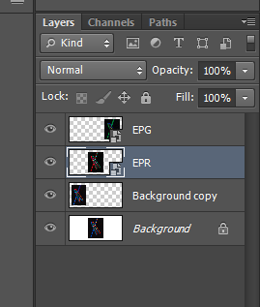

1. Go to the View Menu and scroll over Show then select Grid. Now it’s time to get fussy with the positioning of the images. Work from the top left corner to adjust the width of the frame and space between images – anything left over (at the right and bottom) can be removed with a final crop. Turn off the grid when done.
2. When you are happy with the layout, you may wish to do a final crop, or if necessary repeat step 4 with different values to adjust the canvas size (the colour frame will adjust accordingly).

