Background
Waverley Camera Club (WCC) have specific requirements for entering electronic imaged (also known as EDIs) for competitions. These are based on the Victorian Association of Photographic Societies (VAPS) and these are reviewed annually.
To be eligible to enter WCC competitions, files must meet these detailed specifications. For the current requirements please refer to the Club’s website:
https://www.waverleycameraclub.org/competitions/
The purpose of this document is to outline the steps required to save files from Adobe Elements that are consistent with the WCC requirements. These instructions apply from January 2019.
There are instructions on saving files from Adobe Lightroom and Photoshop are located on the Resources tab on the WCC website.
https://www.waverleycameraclub.org/resources/

Saving files from Adobe Elements
When you have finished editing the image in Adobe Elements, follow these steps:
Step 1 – click on Image, then Size, the Image Size
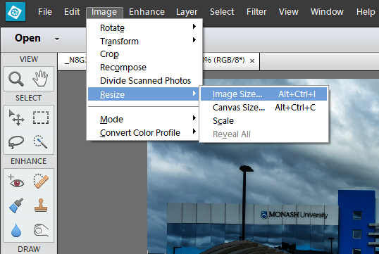

Step 2- Change the Width to 1920 and press the Tab key. If the Height is above 1080 change it to 1080.

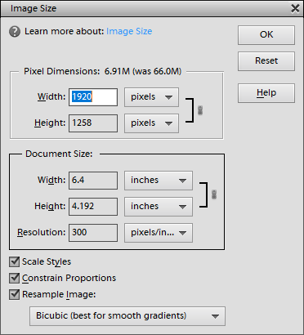
Step 3 - Click OK.
Step 4 – Click File, Save As
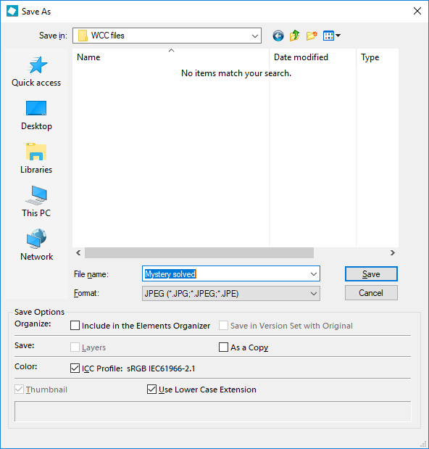
Step 5 – Enter the name of the file, select the file Format as JPEG, ensure the ICC Profile sRGB box is checked and press Save
Step 6 – Ensure the file size is 5Mb or less (5,242,880 bytes).
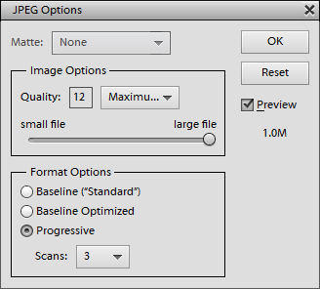
If it is larger than 5Mb reduce the Quality: 1 is the minimum and 12 is maximum.
Then click OK.

Other Information
VAPS website: http://www.vaps.org.au/

WCC has also developed a utility to convert JPEG files into the correct WCC format for competitions. To access this utility use the following URL: http://austvic.com/wcc/ Note that this utility is on a shared service and response times may vary.

