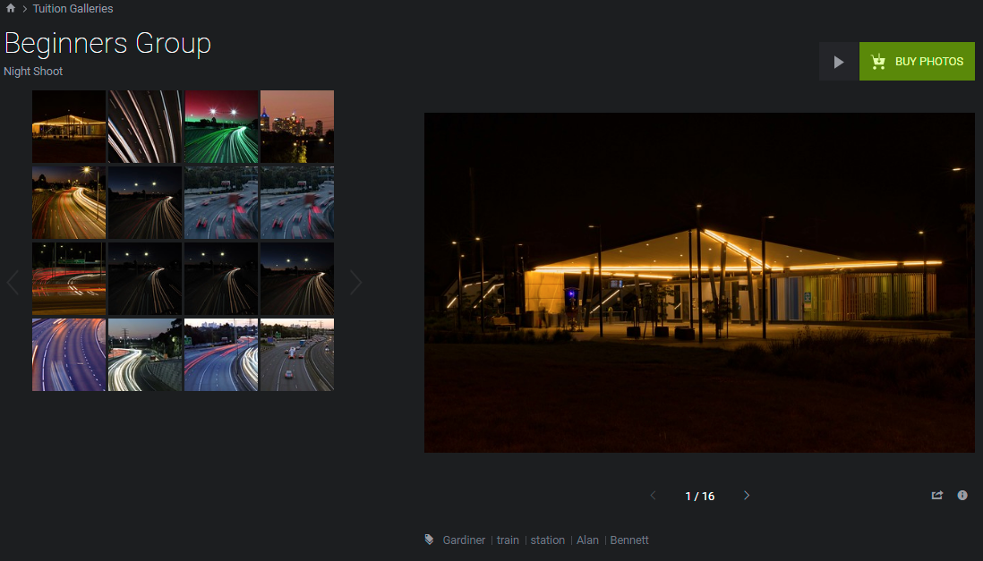

Contents

Background 2

Viewing Existing WCC Galleries 3

Uploading Images into Galleries 5

APPENDIX 1 – Sample email to Members 10

# Background

Waverley Camera Club (WCC) showcases members’ images in via the internet to provide viewing access to competition images and images taken by club members at outings and events. The images are presented in galleries which are topic based collections of images that are usually related to an event or a competition.

After the results of each competition are presented to members at the Club, the images and results are made available for viewing.

WCC use a tool called SmugMug to make available the image galleries.

# Viewing Existing WCC Galleries

To view WCC galleries, navigate to the WCC website then scroll down until you see the Photo galleries heading. Click on the Photo galleries heading to go to the overview of all the galleries, or click on one of the 6 most recently updated galleries below the Photo galleries heading:

<http://www.waverleycameraclub.org/>

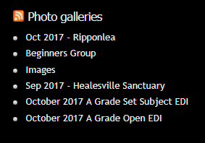

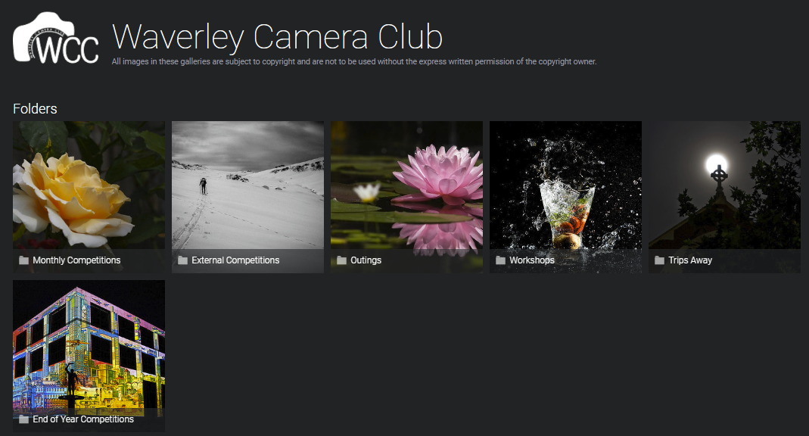

Instructions to upload images are sent out an email to WCC members after each event. See Appendix 1 for a sample email.**Preparing Images**

Images must be in JPEG format. There is no restriction on dimensions (ie the number of pixels in height and width).

The file size is recommended to be 1-8Mb however in practice approximately 500kb (0.5Mb) is sufficient, larger file sizes take longer to upload and do not look any clearer.

The image file should have your name to identify you as the maker, a hyphen, then the name of the image. For example:

**Alan Bennett - Gardiner Train Station**

**Alan Bennett** - **Blurred Melbourne Traffic**

Do not use special characters.

It is recommended to use a descriptive title to assist viewers to identify the subject and/or the location the image was taken.

# Uploading Images into Galleries

Click on the upload link in the email eg:

<https://waverleycc.smugmug.com/upload/PjPDCP/Healesville>

or copy and paste it into your web browser.

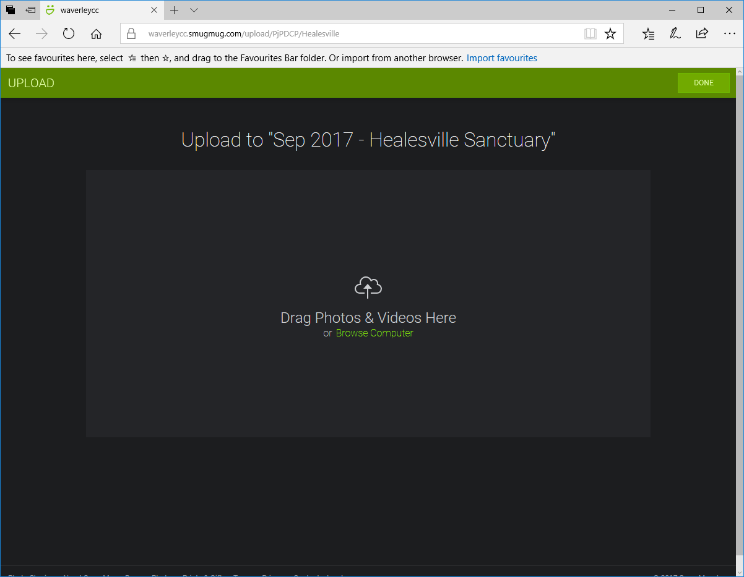

There are 2 ways to upload images.

1. Drag and drop
   1. Open Windows explorer (for Macintosh users it is theFinder)
   2. Navigate to where your images are located
   3. Click on an image and, holding down the mouse button, drag the image across to the SmugMug screen, then release the mouse button
   4. The file will be uploaded, this should take a few seconds to a few minutes depending on the size of the file and the speed of your Internet connection

|  |  |
| --- | --- |
|  |  |

Click then drag to the SmugMug window and “drop” the image by releasing the mouse button.

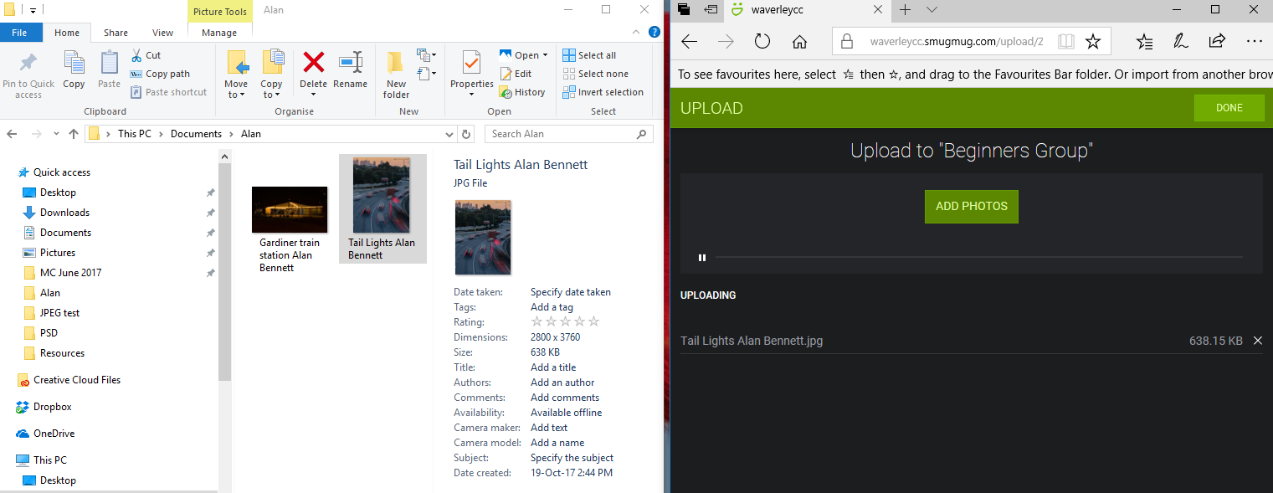

When the image has been copied, a message will be displayed:

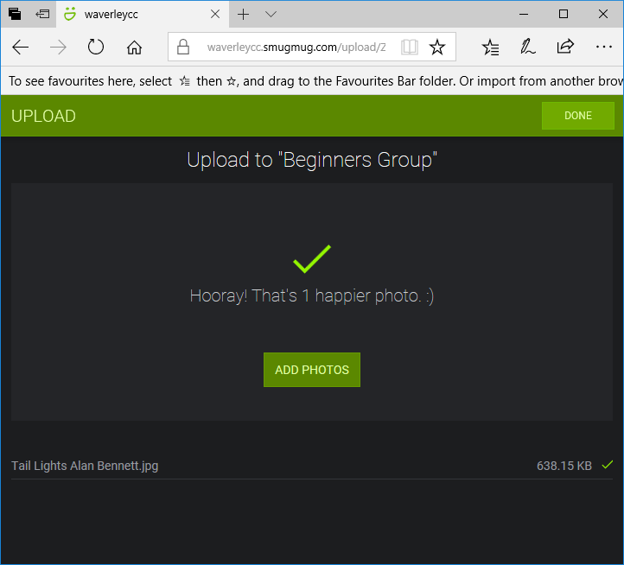

The image will now be visible on the SmugMug site:

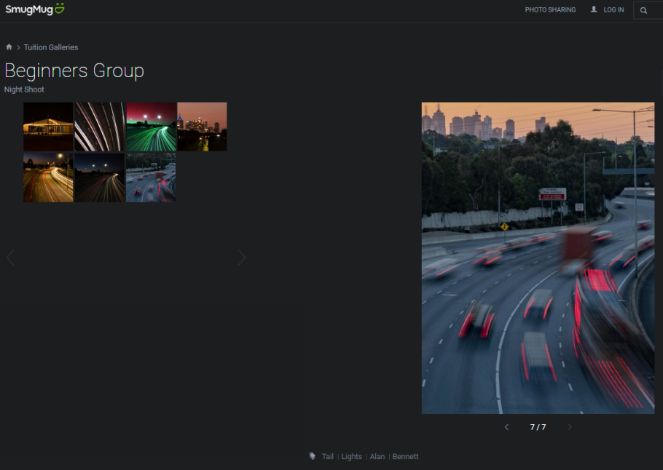

1. Browse your folders and copy a file
   1. Click on Browse Computer (this opens an Explorer window)
   2. Navigate to the location of your files
   3. Click on the file to upload
   4. Click open and it will load into SmugMug

Note – you can use this method to upload 1 file at a time. If you want to upload multiple files it is quicker to select all the images you want to upload at the same time.

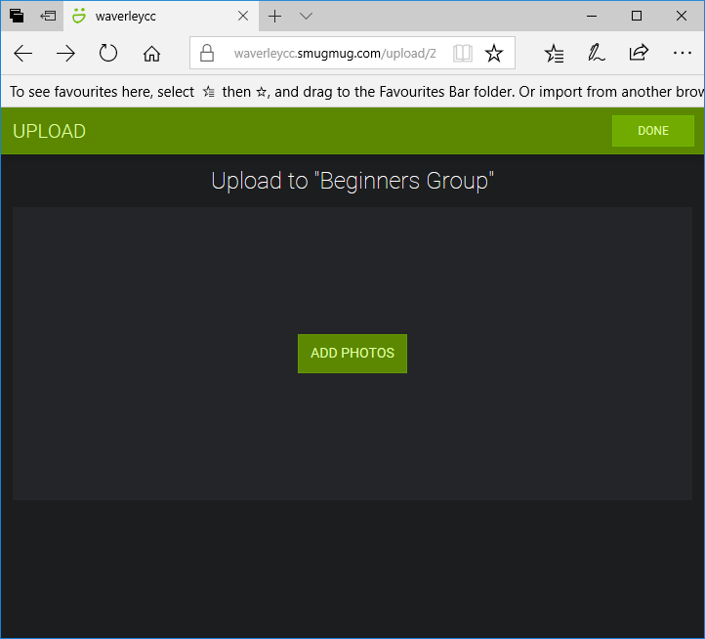

Click on ADD PHOTOS

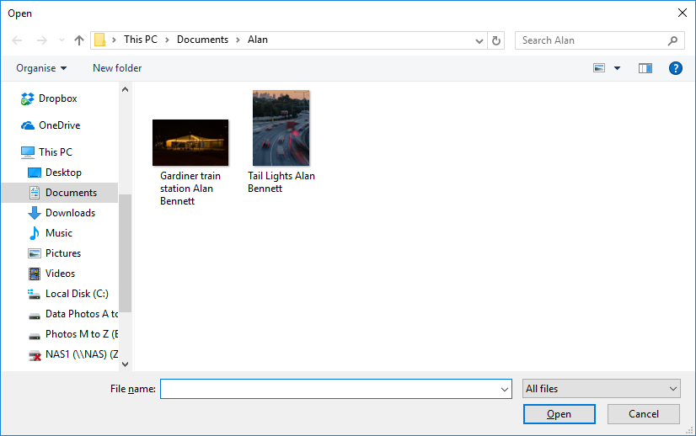

An Explorer window opens, navigate to the location of the file(s) you want to upload.

Click on the image, then click on Open.

The file will then be uploaded to SmugMug



You can now add more photos or click on DONE which will take to you the SmugMug site to review the images loaded.



# APPENDIX 1 – Sample email to Members

Hi Everyone,

If you attended the **South Wharf Outing** on Saturday, this is your opportunity to show everyone what you photographed. A gallery has been created and as usual you can upload your images to it using the instructions below.

Get your photos ready for upload as follows:

1. JPEG format.
2. Any dimensions you like.
3. File size around 1 to 8 MB.
4. Please label with Full Name - Image title.  **NB: Your name and image title are required for images to be uploaded and accepted.**
5. Drag your photos to the window or browse to them on your computer and upload as instructed on the page.

<https://waverleycc.smugmug.com/upload/wshXZ7/evening>

Use the link below to view the images:

<https://waverleycc.smugmug.com/Outings/Monthly-Outings-2018/South-Wharf-at-Night-August-2018/>

We look forward to seeing your photographs.

Cheers,

Outings Coordinator,  
**Waverley Camera Club.  
**[www.waverleycameraclub.org](http://www.waverleycameraclub.org)